**Digital Electronics**

**Class 10**

**Lab 19**

|  |
| --- |
| Lab Objectives:  * Decoder |

# Decoder

## Decoder is a combinational circuit that has ‘n’ input lines and maximum of 2n output lines.

## One of these outputs will be active High, based on the combination of inputs present, when the decoder is enabled.

## That means decoder detects a particular code. The outputs of the decoder are nothing but the min terms of ‘n’ input variables (lines), when it is enabled.

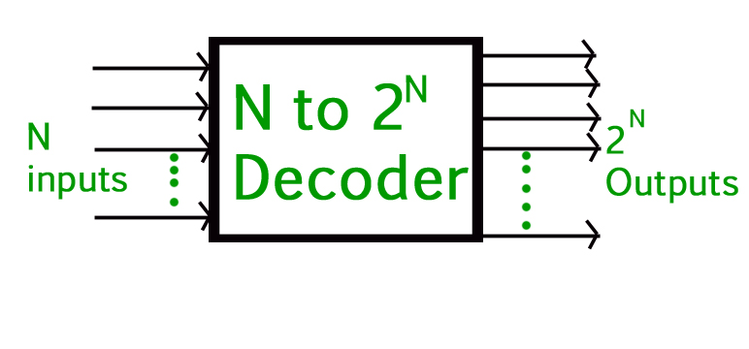

# Input and Output for Basic Logic Gates

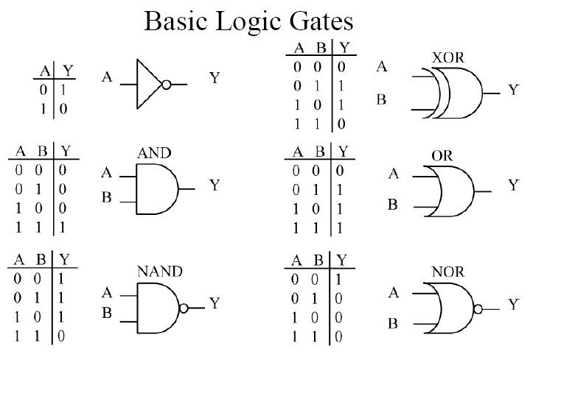

# Truth Table

## Truth table is a tabular representation of all the combinations of values for inputs and their corresponding outputs.

## It is a mathematical table that shows all possible outcomes that would occur from all possible scenarios.

### Example:

## The truth table for the logical AND operator (2-input AND gate).

|  |  |  |
| --- | --- | --- |
| **A** | **B** | **AB** |
| **0** | **0** | **0** |
| **0** | **1** | **0** |
| **1** | **0** | **0** |
| **1** | **1** | **1** |

# 2 to 4 Decoder

## IMG_256Let 2 to 4 Decoder has two inputs A1 & A0 and four outputs Y3, Y2, Y1 & Y0. The block diagram of 2 to 4 decoder is shown in the following figure.

## One of these four outputs will be ‘1’ for each combination of inputs when enable, E is ‘1’. The Truth table of 2 to 4 decoder is shown below.

|  |  |  |  |  |  |  |
| --- | --- | --- | --- | --- | --- | --- |
| Enable | Inputs | | Outputs | | | |
| E | A1 | A0 | Y3 | Y2 | Y1 | Y0 |
| 0 | x | x | 0 | 0 | 0 | 0 |
| 1 | 0 | 0 | 0 | 0 | 0 | 1 |
| 1 | 0 | 1 | 0 | 0 | 1 | 0 |
| 1 | 1 | 0 | 0 | 1 | 0 | 0 |
| 1 | 1 | 1 | 1 | 0 | 0 | 0 |

## From Truth table, we can write the Boolean functions for each output as

Y3=E.A1.A0Y3=E.A1.A0

Y2=E.A1.A0′Y2=E.A1.A0′

Y1=E.A1′.A0Y1=E.A1′.A0

Y0=E.A1′.A0′

## Each output is having one product term. So, there are four product terms in total. We can implement these four product terms by using four AND gates having three inputs each & two inverters. The circuit diagram of 2 to 4 decoder is shown in the following figure.

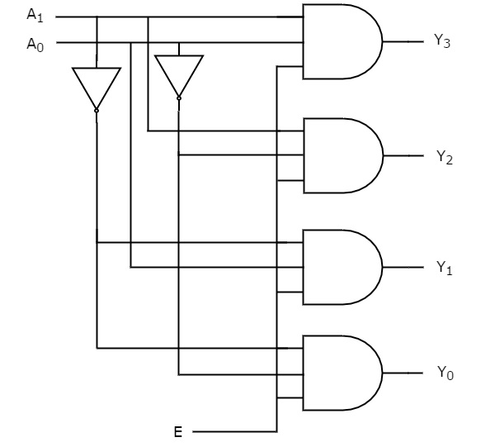

## Therefore, the outputs of 2 to 4 decoder are nothing but the min terms of two input variables A1 & A0, when enable, E is equal to one. If enable, E is zero, then all the outputs of decoder will be equal to zero.

## Similarly, 3 to 8 decoder produces eight min terms of three input variables A2, A1 & A0and 4 to 16 decoder produces sixteen min terms of four input variables A3, A2, A1 & A0.